Palindrome Number
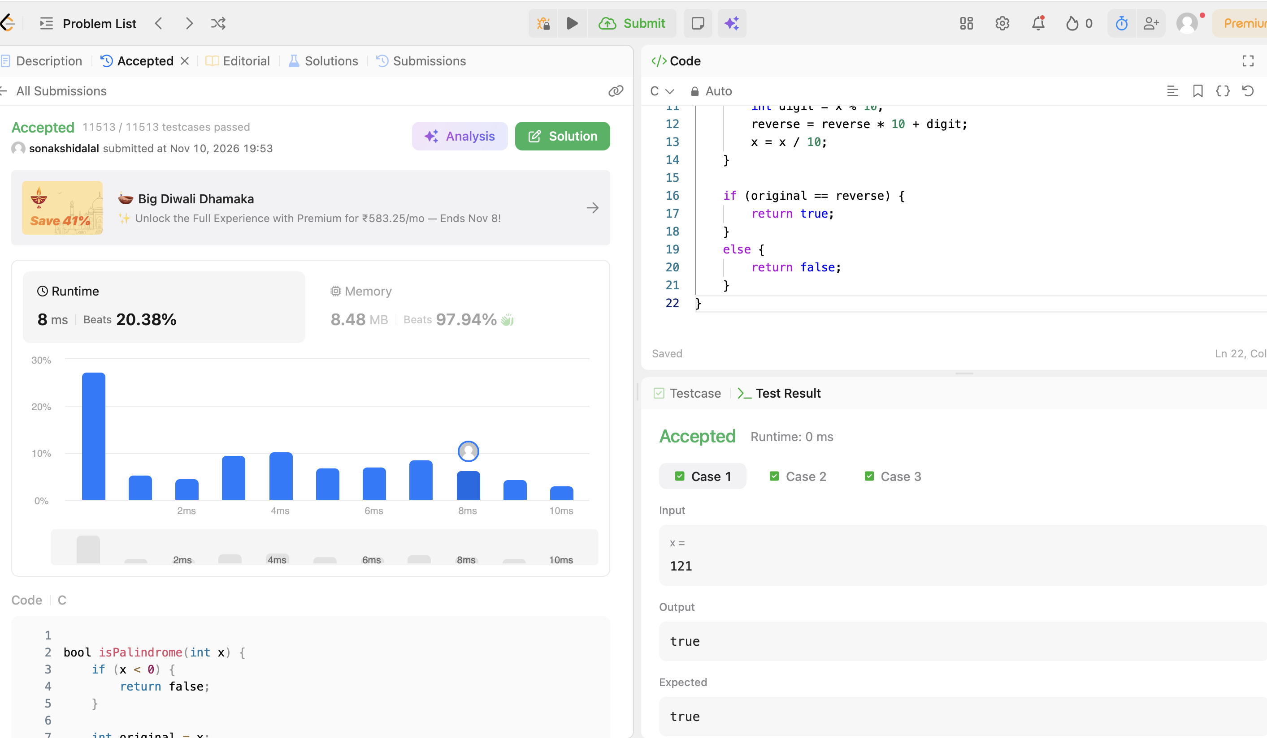
CODE:
bool isPalindrome(int x) {
if (x < 0) {
return false;
}

int original = x;
long long reverse = 0;

while (x > 0) {
int digit = x % 10;
reverse = reverse * 10 + digit;
x = x / 10;
}

if (original == reverse) {
return true;
}
else {
return false;
}
}

